**Name: Victoria Jacqueline Macias Pico**

**W O R K S H E E T S**

**NOTE:** **Your answers must be in blue and bold.**

# UNIT 8

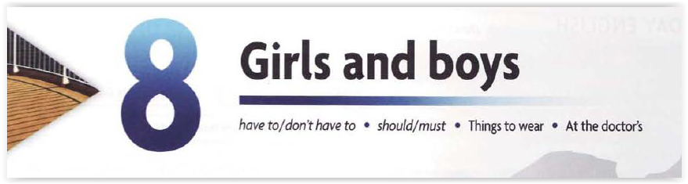

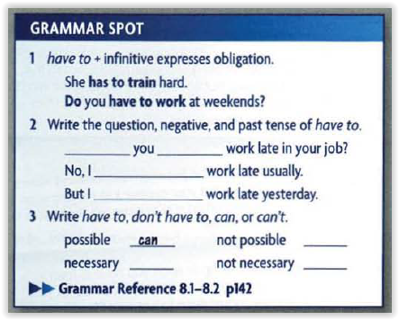

**Do**

**have**

**Don’t have**

**I had**

**Have to**

**Can´t**

**Don´t have to**

**1. Fill in the blanks with the correct form of *have to*:**

1. You have to show your passport at passport control.
2. She has to do homework every evening.
3. Tom had to work late last night.
4. You have to tell him!
5. You don’t have to eat if if you don’t like it!

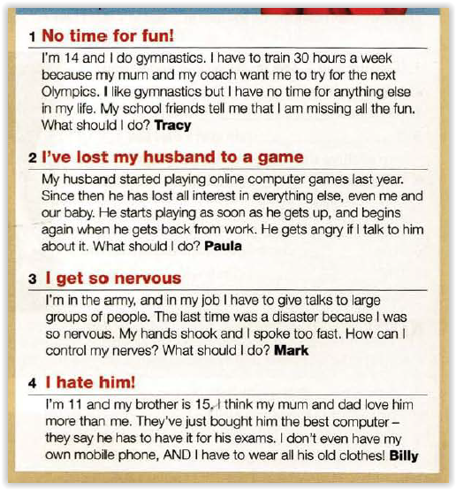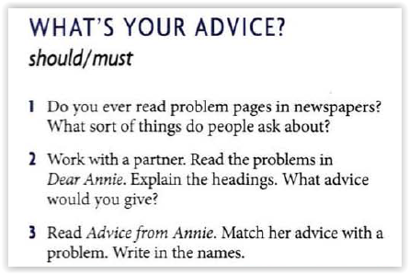

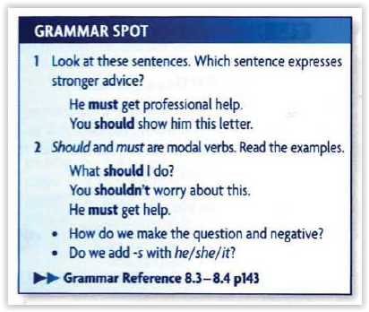

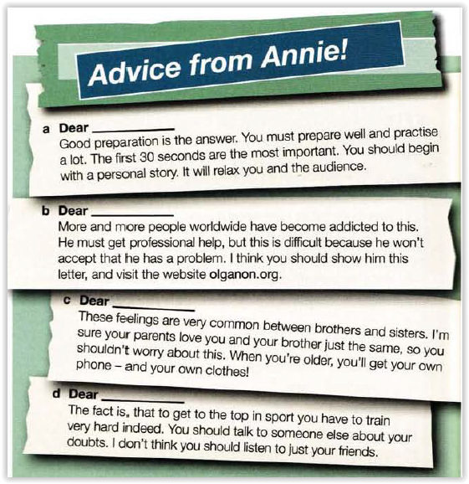

**Mark**

**Paula**

**Billy**

**Tracy**

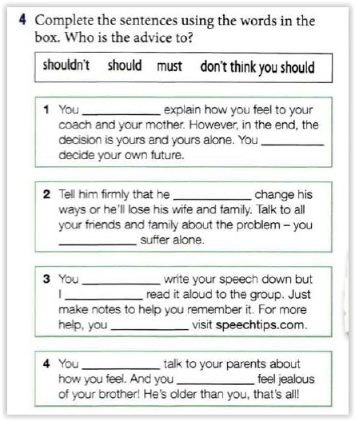

**Should**

**Must**

**Shouldn’t**

**Shouldn’t**

**Should**

**I don’t think you should**

**Should**

**Should**

**Shouldn´t**

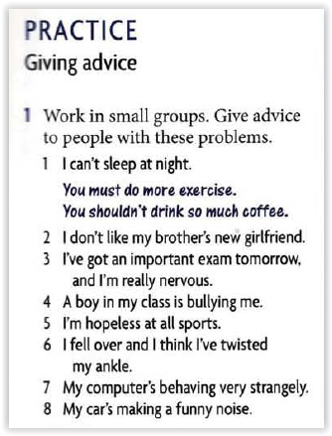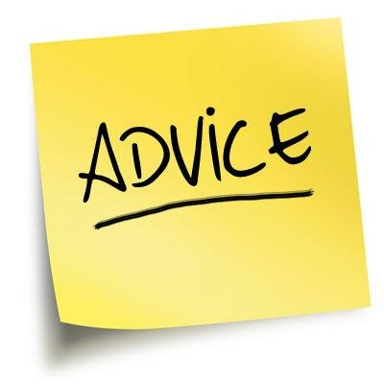

**2. Fill in the blanks with the correct form of *should*:**

1. He should (accept) the position.
2. You shouldn’t allow (not allow) mobile phones in the classroom.
3. Should We admit (admit) that we cheated?
4. They shouldn’t (yell) at him.
5. Pete should (eat) more healthy.

**CLOTHESS:** <https://www.gamestolearnenglish.com/clothes-game/>

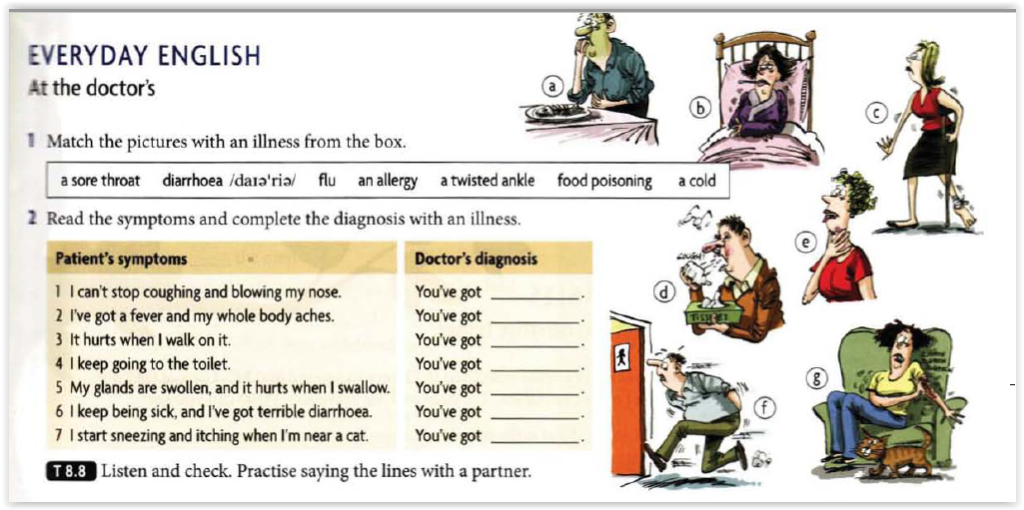

**A flu**

**A cold**

**A twisted ankle**

**A diarrhoea**

**A sore throat**

**A food poisoning**

**An allergy**

**PRACTICE**

**GIVING ADVICE**

1. **I can’t sleep at night.**

* **You must do more exercise.**
* **You shouldn’t drink so much coffee.**

1. **I don’t like my brother’s new girlfriend.**

* **You must accept it so that you don’t fight with you brother,**

1. **I’ve got at important exam tomorrow and I’m really nervous.**

* **You should study hard and you will have more confidence**.

1. **A boy in my class is bullying me.**

* **You must tell him that if he doesn’t leave you alone, he will be expelled from school.**

1. **I’m hopeless at all sports.**

* **you should do another activity.**

1. **I fell over and I think I´ve twisted my ankle.**

* **You must go to the urgent doctor.**

1. **My computer’s behaving very strangely.**

* **You should format it.**

1. **My car’s making a funny noise.**

* **You should fix that car, sell it and buy another car.**